How to Access Past Examination Papers
Did you know that you can access past examination papers using the library catalogue? The easiest way to do that is to just have the “subject codes” of the course you have registered and follow these few steps:
- Type www.vut.ac.za
- Select Library from the VUT website.
- Select “Library Catalogue” on you right hand menu.
- Take your cursor/pointer and put it under “Keyword” search.
- Scroll down and select “Subject” search.
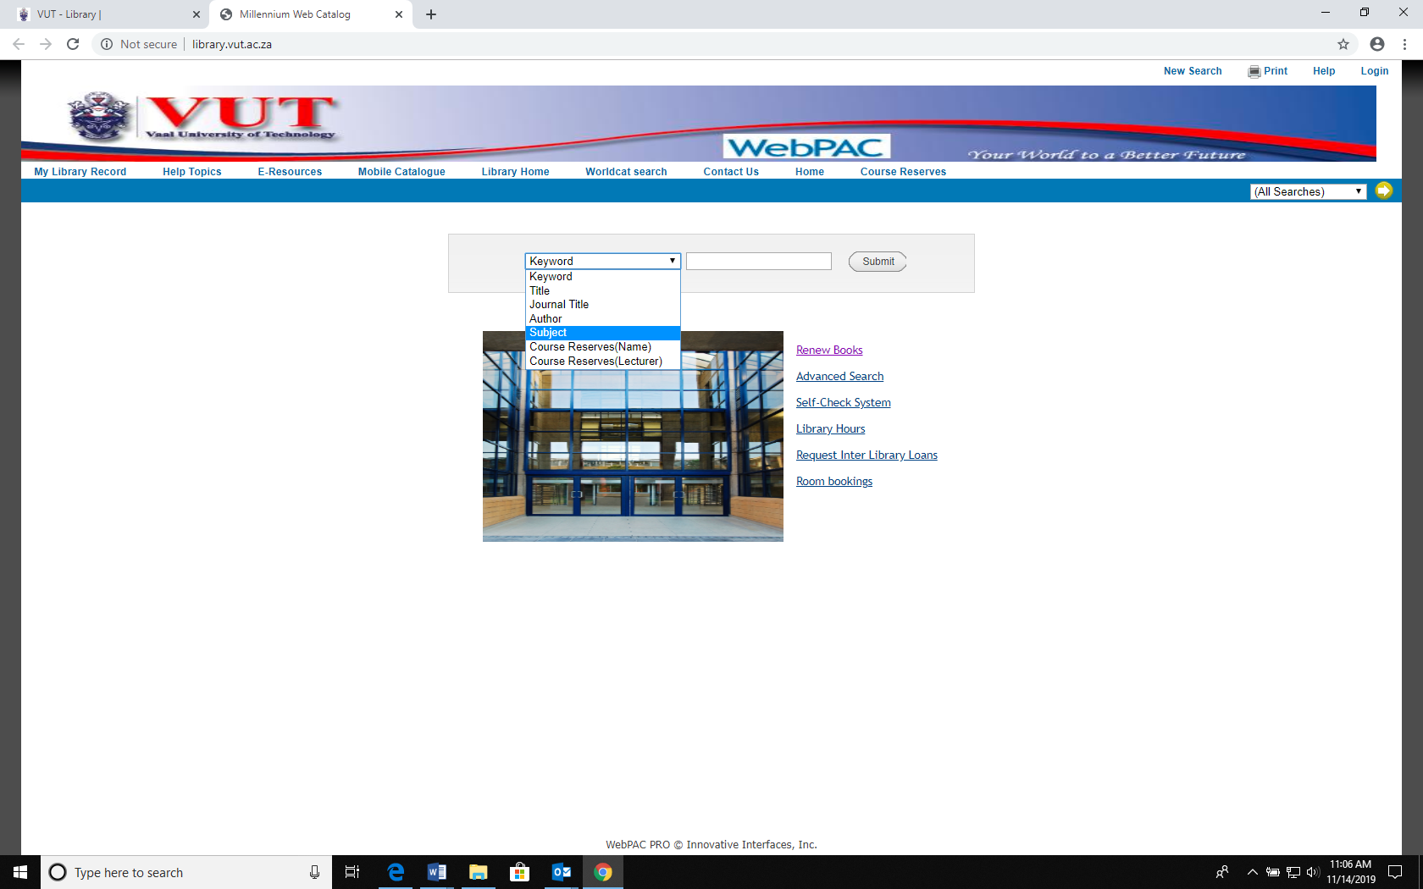

- Type your subject code (Example BBISX1A) and press enter.
- You will then be taken the page below and this will lists of all past exam papers under the subject code you have typed.
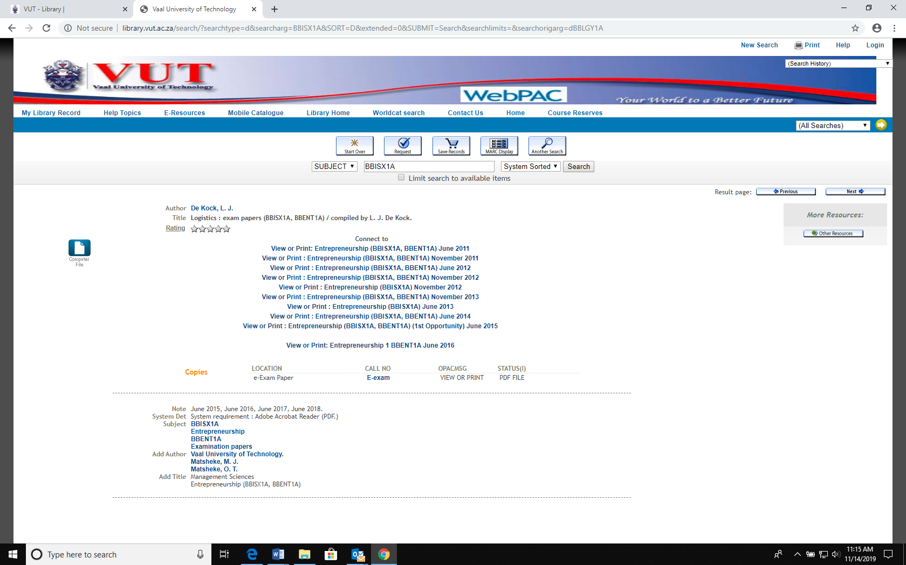
Exam papers under BBISX1A

- From this list you can choose and click exam paper of your choice
- After that you will be directed to the page below.
- To view the exam paper of your choice you will then be requested to identify yourself.
Student
Number
Submit
Surname
- You will then be requested to type your surname and your student or staff number and click submit. 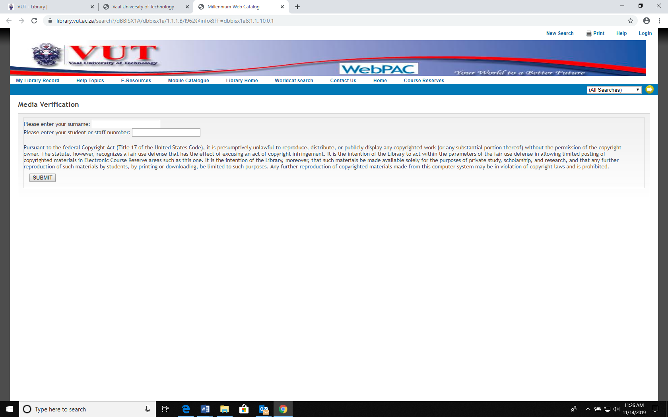

- After identifying yourself you will be taken to this page where you will be able to view the full paper.
- You can view, print (50c per page) or save the paper on your memory stick.
- Kindly note that VUT Libraries do not have answers for these exam papers; you can work in group when trying to find answers.

